SRM II Questionnaire Development Report

19th February, 2018

Aniruddha Singh Jafa

Mayukh Nair

Shruthisagar

Zafar Ali

Introduction

This paper is an analysis of a short questionnaire designed to measure the construct ‘Grade Anxiety’ in a college setting. This questionnaire was formed keeping in mind the day-to-day concerns that many college students seem to have about grades and GPA.

Grade anxiety can be defined as a combination of the feelings of nervousness, uneasiness, and concern regarding one’s measures of academic performance. It manifests itself as an obsessive concern for one's grades and grade point average (GPA) (Santos, n.d.). We adopt this definition due to its simplicity, as well as the fact that the cited article is a resource associated with University of California, Berkeley’s Residence Life portal; this is taken as an indication of the definition’s relevance in capturing what grade anxiety means in a college setting.

Building on the definition, two domains of Grade Anxiety are proposed: **Concern about Performance**, and **Rumination**. As the name suggests, Concern about Performance refers to the individual’s concern regarding one’s academic performance, and the consequences that it may have. Rumination, by this definition, refers to intrusive and repetitive thoughts about grades that makes one anxious or nervous. It should be noted that these domains have not been formally established via factor analysis; they were put forth as conceptual aids meant to help in forming and grouping questions.

Predictive Validity

The construct we are examining for predictive validity is the Fear of Social Judgement, which refers to the fear of being judged by peers and professors on the basis of GPA. Our prediction is that Grade Anxiety is correlated positively with Fear of Social Judgement. This prediction is based partly on informal discussions we had with our peers, as well as the fact that the act quantifying academic success (or any parameter) makes it easier to make comparisons, which may instill a fear of being judged. Additionally, People with Social Anxiety Disorder fear and avoid the scrutiny of others (Stein & Stein, 2008); we wanted to see if a similar claim can be made for Grade Anxiety, though it should be noted that we are not claiming that Grade Anxiety is a disorder.

We shall also examine the link between GPA and Grade Anxiety, but make no claims about whether or not there is a link between them, and what the nature of this link is.

Methods

After a period of discussion, three items were chosen for each of the two domains based on which items seemed to fit the definitions of the domains more closely. In addition to these 6 items, there was one item to deal with predictive validity. Lastly, there was an item that asked candidates for their GPA; this item was included to provide us with the option of additional analysis, but we make no predictive claims about the link between Grade Anxiety and GPA. The complete list of items is attached in the Appendix.

The questionnaire was sent to the undergraduate student populace using a survey designed on Google Forms. The survey was designed to ensure anonymity, and did not capture any information that could be directly tied to a respondent. A prominent disclaimer at the beginning of the survey was also present to assure the respondents that data being collected through this form could not be traced back to them. Ensuring anonymity was all the more necessary because of the item that asked candidates for their GPA.

The survey was divided into three sections. All questions were made mandatory. Section 1 collected the respondents’ gender and academic year they were enrolled in. Section 2 consisted of seven items. A 5-point Likert scale was used to assess how strongly the respondent agreed with each item. The verbal anchors used ranged from 1 - “Strongly disagree” all the way to 5 - “Strongly agree”. The other anchors were 2 - “ Strongly disagree”, 3 - “Neither agree nor disagree”, and 4 - “Somewhat agree”. Which anchor each number was associated with was specified at the beginning of Section 2. The order of the questions was shuffled with every respondent to prevent order bias. All of the items were positively coded, with the verbal anchors implying an ascending scale from least anxiety to high anxiety. Section 3 collected the respondent’s cumulative GPA.

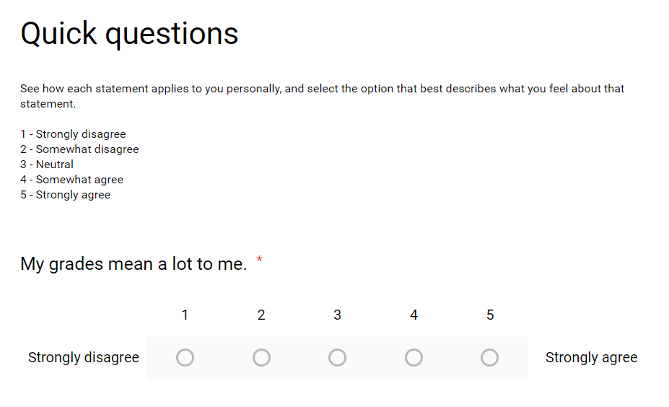

*Figure 1: A sample item*

The data collected was exported to CSV format, cleaned and pre-processed with Microsoft Excel and analysed using a script written in R which used the *readr* and *psych* libraries. Once all data points were defined, the *alpha*, *corrtest* and *lowercor* functions were used to run alpha reliability and correlation tests on the data. The *t.test* function was used to run a t-test and compare the means on each factor per gender.

An Overall Anxiety Score for each participant was calculated by finding the mean of the 6 items used to measure Grade Anxiety. Scores for Rumination and Concern about Performance were also calculated for each participant after finding the mean for the items associated with each domain.

Results

We collected data from 73 participants (26 Male, 45 Female, 2 Others). The reliability alpha for the 7 items used to measure Grade Anxiety was found to be 0.8, which is well within the accepted range of 0.7-0.95 (Kline, 2000; DeVellis, 2012).

Further, R’s Reliability-if-an-item-is-dropped values ranged between 0.76 and 0.82 indicating that all items contributed to the scale total and removing any item will probably not improve the reliability by a significant margin. We ran correlation tests between the two domains, the Overall Anxiety Score, and CGPA. Table 1 and 2 show the correlation values and p-values as reported by R. As we can see, the two factors are moderately correlated with each other (Pearson’s *r* = 0.66). We also note that Fear of Social Judgement shows a weak positive correlation with Concern about Performance (Pearson’s *r* = 0.35), Rumination (Pearson’s *r* = 0.28), but almost none with CGPA (Pearson’s *r* = -0.02). Additionally, CGPA shows very weak correlation with Concern about Performance (Pearson’s *r* = 0.16) and the Overall Anxiety Score (Pearson’s *r* = 0.13), but the p-values were not significant (0.18 and 0.27 respectively).

The t-tests done to check for differences between gender revealed that there was no significant difference between males and females on any of the factors.

Regarding predictive validity, the correlation between the Overall Anxiety Score and Fear of Social Judgement was moderately positive (Pearson’s *r* = 0.35) and significant (p <= 0.02), which shows that the questionnaire demonstrates predictive validity.

|  |  |  |  |  |  |
| --- | --- | --- | --- | --- | --- |
|  | CGPA | m.Perf | m.Rumin | m.Judge | overall |
| CGPA | 1.00 |  |  |  |  |
| m.Perf | 0.16 | 1.00 |  |  |  |
| m.Rumin | 0.08 | 0.66 | 1.00 |  |  |
| m.Judge | -0.02 | 0.35 | 0.28 | 1.00 |  |
| overall | 0.13 | 0.91 | 0.91 | 0.35 | 1.00 |

*Table 1: Correlation Values, only the lower triangle matrix is shown here for brevity*

|  |  |  |  |  |  |
| --- | --- | --- | --- | --- | --- |
|  | CGPA | m.Perf | m.Rumin | m.Judge | overall |
| CGPA | 0.00 | 0.72 | 1.00 | 1.00 | 0.80 |
| m.Perf | 0.18 | 0.00 | 0.00 | 0.02 | 0.00 |
| m.Rumin | 0.50 | 0.00 | 0.00 | 0.08 | 0.00 |
| m.Judge | 0.89 | 0.00 | 0.02 | 0.00 | 0.02 |
| overall | 0.27 | 0.00 | 0.00 | 0.00 | 0.00 |

*Table 2: p-values (Entries above the diagonal are adjusted for multiple tests.)*

Conclusion

The questionnaire has high reliability, and also demonstrates predictive validity - there is a significant correlation between the Overall Anxiety Score, and Fear of Social Judgement. However, while we know a significant link between Grade Anxiety and Fear of Social Judgement exists, we don’t yet know the nature of this relationship.

As mentioned previously, a theoretical limitation of the questionnaire is that the two domains proposed have not been established formally. Performing exploratory factor analysis is recommended.

An observation we made after administering this questionnaire was that contrary to our internal apprehension, the respondents did share their GPA once they were guaranteed anonymity.

Appendix

1. Questionnaire

Listed below are the questions used to measure Grade Anxiety, grouped under their respective domains. Statements v1, v4, and v5 belong to Concern about Performance, whereas statements v2, v3, and v6 belong to Rumination. Finally, we had one more question associated with predictive validity (v7), as well as one question asking candidates about their GPA.

1. Which year are you in? Year
2. Gender
3. My grades mean a lot to me. v1
4. I find myself thinking about grades very often. v2
5. I am not able to distance myself from thoughts about grades and coursework. v3
6. Waiting for my grades to come out is a stressful experience v4
7. I worry excessively about about how my GPA might affect my future v5
8. Thinking about grades makes me nervous. v6
9. I think my peers and professors judge me based on my GPA v7
10. Your cumulative GPA: CGPA
11. Correlation matrix

|  |  |  |  |  |  |  |  |
| --- | --- | --- | --- | --- | --- | --- | --- |
|  | v1 | v2 | v3 | v4 | v5 | v6 | v7 |
| v1 | 1.00 |  |  |  |  |  |  |
| v2 | 0.44 | 1.00 |  |  |  |  |  |
| v3 | 0.24 | 0.45 | 1.00 |  |  |  |  |
| v4 | 0.42 | 0.60 | 0.15 | 1.00 |  |  |  |
| v5 | 0.36 | 0.50 | 0.24 | 0.57 | 1.00 |  |  |
| v6 | 0.43 | 0.66 | 0.23 | 0.70 | 0.50 | 1.00 |  |
| v7 | 0.28 | 0.20 | 0.12 | 0.38 | 0.19 | 0.36 | 1.00 |

*Table 3: Inter-item correlation*

|  |  |  |  |  |  |  |  |
| --- | --- | --- | --- | --- | --- | --- | --- |
|  | v1 | v2 | v3 | v4 | v5 | v6 | v7 |
| v1 | 0.00 | 0.00 | 0.27 | 0.0 | 0.02 | 0.00 | 0.14 |
| v2 | 0.00 | 0.00 | 0.00 | 0.0 | 0.00 | 0.00 | 0.35 |
| v3 | 0.04 | 0.00 | 0.00 | 0.4 | 0.27 | 0.27 | 0.40 |
| v4 | 0.00 | 0.00 | 0.20 | 0.0 | 0.00 | 0.00 | 0.01 |
| v5 | 0.00 | 0.00 | 0.04 | 0.0 | 0.00 | 0.00 | 0.35 |
| v6 | 0.00 | 0.00 | 0.05 | 0.0 | 0.00 | 0.00 | 0.02 |
| v7 | 0.02 | 0.09 | 0.30 | 0.0 | 0.10 | 0.00 | 0.00 |

*Table 4: p-values for inter item correlation (Entries above the diagonal are adjusted for multiple tests.)*

III. Plots

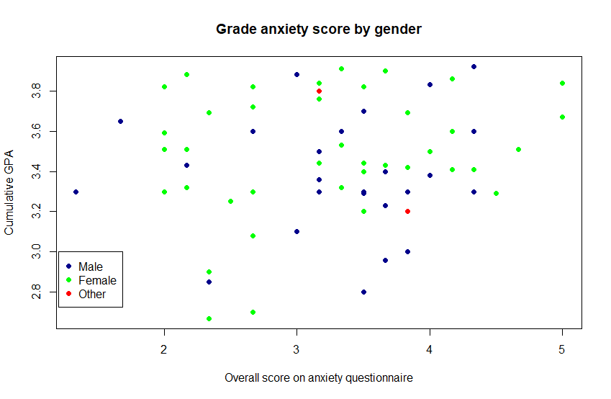

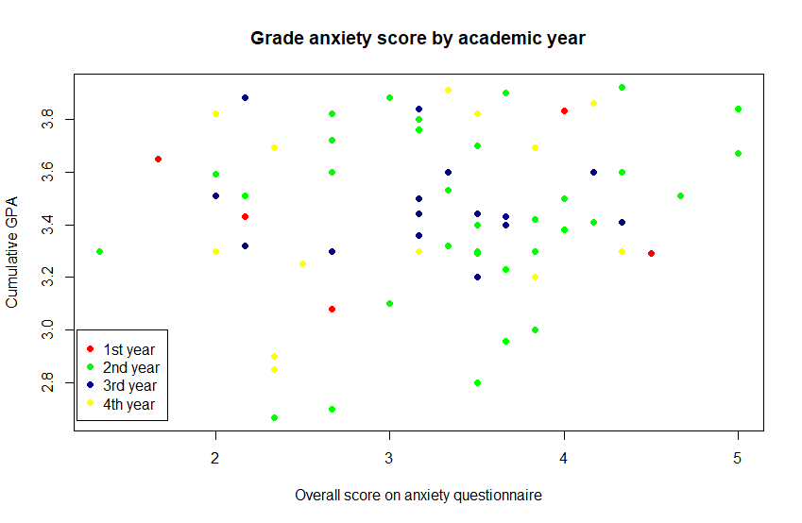

References

Santos, M. D. (n.d.). *Grade Anxiety and other Hobgoblins of the Mind*.

Kline, P. (2013). *Handbook of psychological testing*. Routledge.

DeVellis, R. F. (2016). *Scale development: Theory and applications* (Vol. 26). Sage publications.

Stein, M. B., & Stein, D. J. (2008). Social anxiety disorder. *The Lancet*, *371*(9618), 1115-1125.